Master Exception Handling in Spring Boot
Traditional Exception Handling & @ExceptionHandler & @ControllerAdvice

Why Exception Handling Exists ??
In real systems:
- Databases fail
- Data is missing
- APIs break
- Users send bad input
If exceptions are not handled properly:
• APIs return 500 without meaning
• Logs become unreadable
• Clients cannot react correctly
Exception handling is not about avoiding crashes —It is about controlling failure behaviour.
Spring gives a structured mechanism so that:
Errors become predictable responses, not random crashes.

How Spring Actually Executes This ?? (Internal Flow)
Normal request:
Client → DispatcherServlet → Controller → Service → Repository
If exception occurs:
Service throws Exception
→ DispatcherServlet catches it
→ Looks for @ExceptionHandler
→ If not found in controller
→ Looks in @ControllerAdvice
→ Builds response
→ Sends JSON error
Spring never lets exceptions escape blindly — if configured properly.

APPLICATION SETUP — ECOMMERCE APP
Package Structure
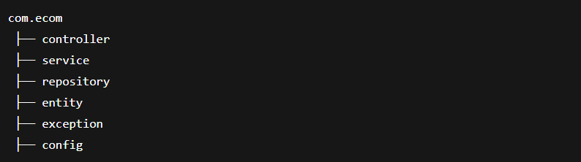
ENTITY LAYER
Product.java
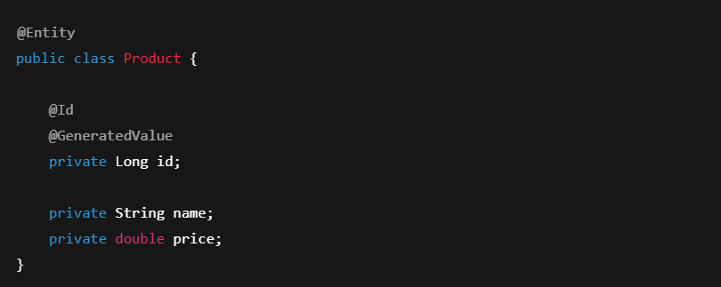ErrorResponse.java
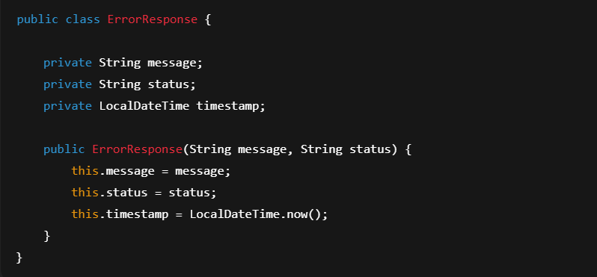

EXCEPTION CLASS
ProductNotFoundException.java
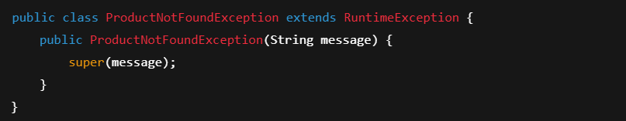
REPOSITORY
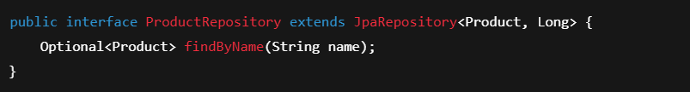
SERVICE
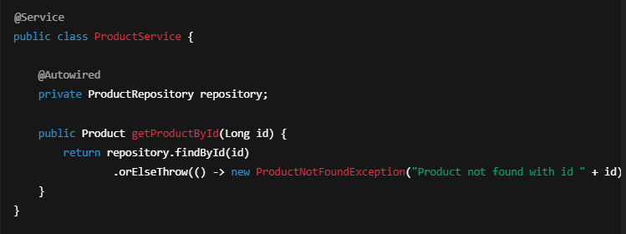

CASE 1 — TRADITIONAL TRY-CATCH – Method Level (BAD PRACTICE)
ProductController.java
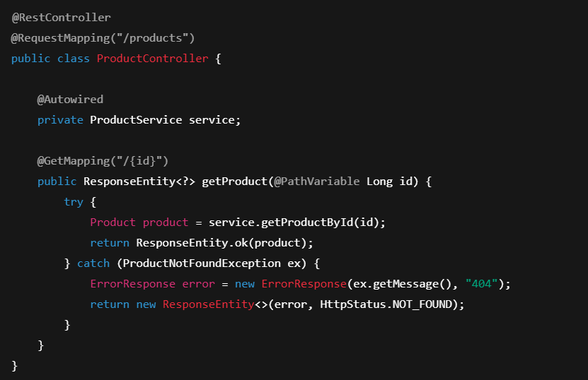
What is happening conceptually?
In the traditional model, every controller method becomes responsible for:
• Business logic routing
• HTTP mapping
• Exception translation
• Error response creation
This violates Single Responsibility Principle.
The controller is no longer just a request handler — it becomes an error-processing engine.
As the system grows:
• 10 controllers → 50 try-catch blocks
• 100 controllers → 500 try-catch blocks
Now error handling logic is:
• Try-catch in every method
• Duplicate logic
• Hard to maintain / modify globally
• No central control
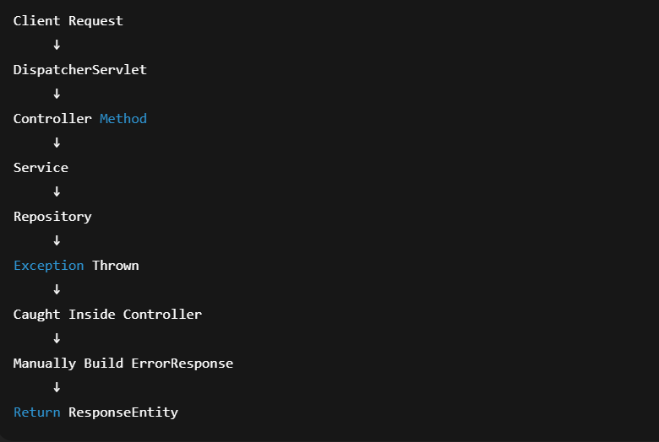

What is the hidden architectural problem?
Spring already has a central request pipeline via DispatcherServlet.
By writing try-catch inside controllers, we are:
→ Bypassing Spring’s exception resolution mechanism
→ Hard-coding behaviour into business controllers
This blocks Spring from doing what it is designed for.

Why This Is a Dead-End Design
This design fails in enterprise systems because:
• No centralized control
• No global logging strategy
• No consistent HTTP mapping
• No reuse
This is why no large production system uses controller-level try-catch.

CASE 2 — @ExceptionHandler (CONTROLLER LEVEL)
ProductController.java
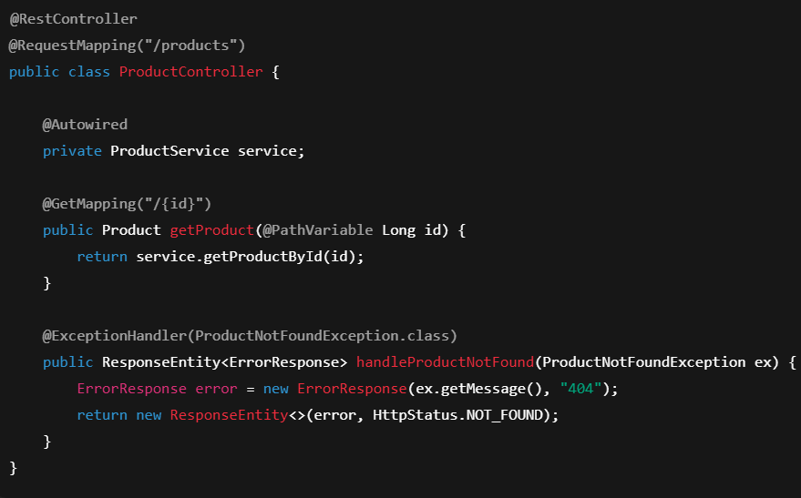

What problem does @ExceptionHandler solve?
Instead of polluting every API method with try-catch:
Spring allows separating normal flow from error flow.
Now:
• Controller methods contain only happy path logic
• Error logic is extracted into a dedicated handler method
This is the first step toward clean architecture.
What changed architecturally?
- Earlier Exception handling = Controller responsibility
- Now Exception handling = Framework responsibility
The controller only declares:
- “If this exception occurs, use this method.”
This is Inversion of Control applied to error handling.

Runtime Flow With @ExceptionHandler
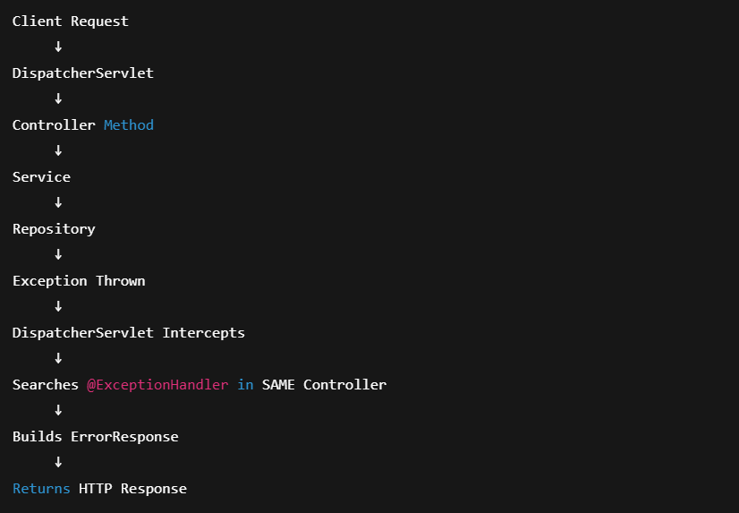

@ExceptionHandler Has Problem with MULTIPLE CONTROLLERS PROBLEM
Add OrderController :
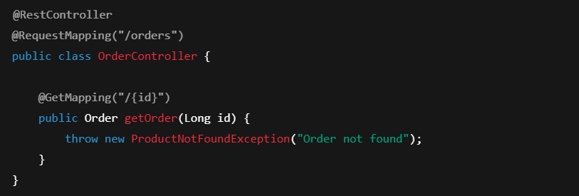Result:
❌ Exception not handled
Because handler is inside ProductController only.

Limitation
This handler is scoped only to this controller.
- ProductController exceptions → handled
- OrderController exceptions → unhandled
This creates fragmented exception management.
Each Controller should have dedicated @ExceptionHandler Method Redundancy !!!

CASE 3 — @ControllerAdvice (ENTERPRISE SOLUTION)

What happens in real systems?
Large systems have:
• 50+ controllers
• 100+ custom exceptions
If each controller manages its own exceptions:
We get distributed error logic.
This causes:
• Inconsistent error formats
• Inconsistent HTTP codes
• Impossible governance
We have moved from chaos to organized chaos .

FLOW — WITHOUT CENTRALIZED HANDLING
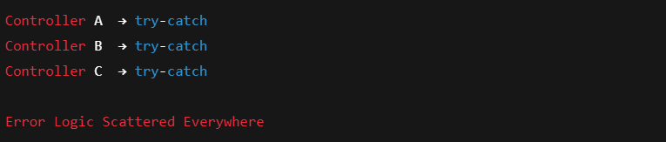
@ControllerAdvice & @RestControllerAdvice allows us to handle Exceptions Globally

GlobalExceptionHandler.java
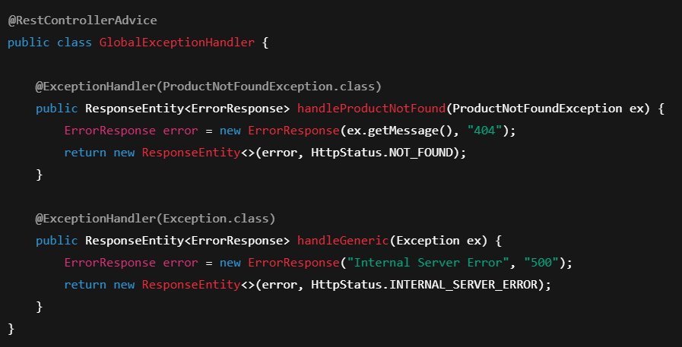
Now:
All controllers → Central handler
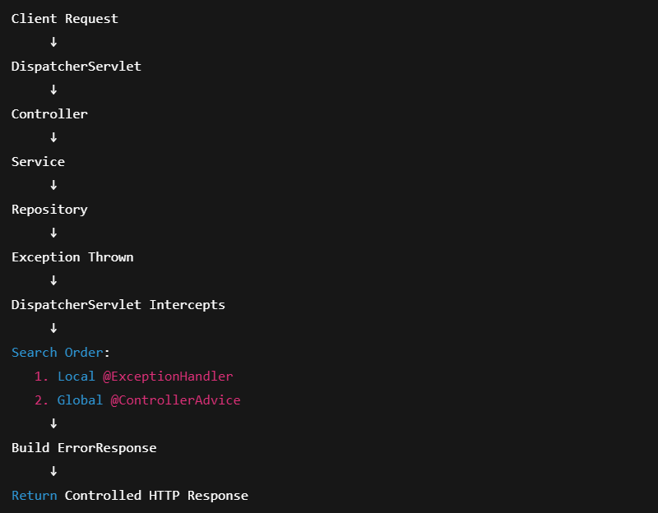

Why does @ControllerAdvice exist?
Spring MVC internally has:
DispatcherServlet → HandlerAdapters → ExceptionResolvers
@ControllerAdvice registers a global ExceptionResolver.
It becomes part of the framework pipeline itself.
Now exception handling is no longer tied to controllers.

FLOW — WITH ControllerAdvice / RestControllerAdvice
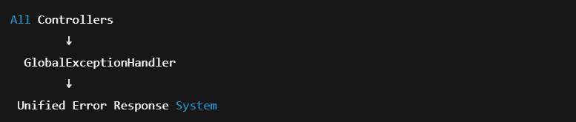

What changed architecturally?
Exception handling moved from:
Controller Layer → Framework Infrastructure Layer
This is exactly how logging, security, transactions also work.
• One place to change error format
• One place to log errors
• One place to map HTTP codes
This is why every enterprise Spring system uses ControllerAdvice.

@ControllerAdvice vs @RestControllerAdvice
Feature | ControllerAdvice | RestControllerAdvice
Purpose | Global handler | Global REST handler
Response | View / JSON | JSON only
Use in APIs | ❌ | ✅

FINAL SUMMARY (ARCHITECTURAL STORY)
In a Spring Boot system:
Normal requests are centralized through DispatcherServlet.
Spring Boot starts → DispatcherServlet created → Controllers registered → Requests flow normally.

When failure occurs:
Exception thrown → DispatcherServlet intercepts → Searches handlers → Builds error response → Returns controlled JSON.
Your application never crashes blindly — if you design it correctly.

Without structured exception handling:
Each controller becomes a mini error server.
This creates:
• Tight coupling
• High duplication
• Unstable APIs
Spring’s design intent is different:
Controllers → Handle business requests
Framework → Handle cross-cutting concerns
Exception handling is a cross-cutting concern like:
• Logging
• Security
• Transactions
@ControllerAdvice elevates exception handling into the framework layer.
This transforms runtime failures into controlled system behavior.
Instead of random crashes:
Failures become part of your API contract.
That is real backend engineering maturity.

Interview- Questions
1. Why is try-catch in controllers considered bad design?
Because it violates separation of concerns and spreads error logic across business code, increasing maintenance risk.

2. How does Spring find the correct @ExceptionHandler?
DispatcherServlet scans:
- Controller local handlers
- @ControllerAdvice beans
- Most specific exception match wins

3. What happens if two ControllerAdvice handle same exception?
Spring chooses the most specific handler. Ambiguity throws startup error.

4. Can @ExceptionHandler catch runtime and checked exceptions?
Yes. Spring matches by exception type hierarchy.

One-Page Mental Model
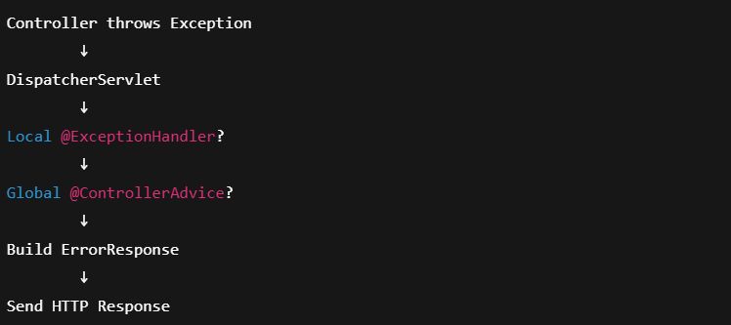

Enterprise Relevance
Without centralized handling:
• APIs become inconsistent
• Clients break
• Logs become noisy
Every production-grade system uses global exception handling.

Hidden Traps
Trap | Why it Happens
ExceptionHandler not called | Wrong package scanning
Multiple handlers conflict | Ambiguous exception mapping
Proxy issues | Advice applied through AOP

Core Definitions
Term | Meaning
Exception | Abnormal condition disrupting normal flow
@ExceptionHandler | Handles exceptions inside a controller
@ControllerAdvice | Global exception handler for all controllers
@RestControllerAdvice | @ControllerAdvice + @ResponseBody
ErrorResponse | Custom DTO sent to client
DispatcherServlet | Central request router

